|  |
| --- |
| **TurnQuest Everest Insurance Suite**  **General Insurance System(GIS)**  **Technical Setup User Manual** |



**01ST September 2014**

**Contents**

1 General Insurance Setup Screens

1.1 Underwriting

1.1.1 Parameters

1.1.2 Sequences

1.1.3 Classes

1.1.4 Subclasses

➢ *If for a given subclass, the system will always enforce that the risk id, vehicle registration for example, is unique hence ensuring no double debiting.*

1.1.5 Product groups

1.1.6 Products

➢ *If for a product is flagged as being a multi-class, then and only then can one attach more than one sub-class to the product.*

1.1.7 Product Sub Classes

1.1.8 Design Schedule Screens

1.1.9 Cover Types

1.1.10 Premium Items (Premium Sections)

1.1.11 Premium Item Rates

1.1.12 Binders

1.1.13 Commission rates at sub class level and at binder level

1.1.14 Clauses

1.1.15 Flood Zone/Earthquake (Risk Zones) And Territories

1.1.16 REVENUE ITEMS

1.1.17 Other Interested Parties & Premium Financier

1.1.18 Predefining Reports to Be Attached To Emails When Transacting

1.1.19 Endorsement Remarks

1.1.20 Perils And Attaching To Binders/Premium Masks

1.1.21 Limits of Liability & Attaching Them To Sub-Classes

1.2 claims

1.2.1 Causations & Attaching Them To Classes

1.2.2 Events & Catastrophes

1.2.3 Road Conditions

1.2.4 Claim Statuses

1.2.5 Disability Scales

1.2.6 Penalties Setup

1.2.7 Claim Payment Items

1.2.8 Reasons For Pending

1.2.9 Claim Completion Remarks

1.2.10 Designing Of Claim Forms

1.3 reinsurance

1.3.1 Treaties and Treaty Setups

1.4 Risk Categories

1.5 XOL Treaties

1.6 Unique Product setup:-

# General Insurance Setup Screens

This are all the set up screens required for various transactions in GIS

## Underwriting

### Parameters

The system will have the capability to define the various parameters to depict the various business rules which may vary from one organization to another.

Parameter definition Inputs;

* Parameter Name
* Parameter Value
* Parameter Status
* Description
* *Some of the parameters currently in the GIS system are Note Any Parameter change should done in conjunction with Turnkey Africa;*

|  |  |
| --- | --- |
| **Parameter Name** | **Parameter Description** |
| * CERTIFICATE_MODULE_ENABLED | *This indicates if the certificate module is active or not* |
| * MPSD_ROAD_MAX | *Marine Stamp Duty Maximum For Road Conveyance. Null Or Zero If No Maximum* |
| * CLAIMS_BPM | *Enables Or Disables BPM For Claims* |
| * MEMO_CLASS_LVL | *If N Memo Wont Depend On Class of business* |
| * CLM_DOCS | *If Y Then The Claim Docs Tab Is Visible on the claim screens* |
| * GEN_SPR_SERIAL |  |
| * SINGLE_CASH_LOSS | *The Single Claim Cash Loss Limit Required For Informing The Reinsurers* |
| * CLAIM_REMARKS_MANDATORY | *[Y] Cannot Authorize Without Entering A Claim Remark* |
| * EVENT_CASH_LOSS | *The Single Event Cash Loss Limit Required For Informing The Reinsurers* |
| * RENEWAL_PERIOD_ALLOWED | *The Period Renewal Or Endorsement Transaction Can Be Done In Months* |
| * MARINE_CERT_SEQ | *The Sequence Number For Marine Certificates* |
| * CLM_NEW_RESERVE | *The Limit For New Reserves* |
| * ACCUMULATION_LOGGING | *Values Are Yes Or Y To Enable Logging Or No Or N To Disable Logging Of The Defined Accumulation Groups. The Status Has No Effect Whether Active Or Inactive* |
| * SHOW_INSURED_ON_DBT | *If Set To Y The Insured Details Will Be Displayed Whenever The Parameter Is Used Else Details Not Shown.* |
| * MAXSERVICINGFEE | *The Maximum Servicing Fee Chargeable* |
| * POLDOCSPATH | *Policy Document Path* |
| * POLDOCSOPENPWD | *Policy Document Open Password* |
| * POLDOCSMODIFYPWD | *Policy Document Modify Password* |
| * MINSERVICINGFEE | *The Minimum Servicing Fee Chargeable* |
| * ALLOWEDITCLAIMRI | *To Allow To Edit Claim Ri Rates During The Revision Transactions* |
| * CLM_REF_NUM | *If N Uses The Ggt_Trans Number Else Use Ggt_Clm_Ref_No* |
| * PARTIAL_PYMNT_COMM | *If Commission Is Payable On Partial Payment Of Receipt* |
| * RI_PREM_DIST_METHOD | *Method Of Apportioning Reinsurance Premium - Valid Values Are (Incremental/Fresh)* |
| * DEBITNOFORMAT | *Debit Note Number Format* |
| * DEBITSERIAL | *Debit Note Number Format* |
| * DEBITSRLENGTH | *Debit Note Serial Length* |
| * CREDITNOFORMAT | *Credit Note Number Format* |
| * CREDITSERIAL | *Credit Note Number Format* |
| * CREDITSRLENGTH | *Credit Note Serial Length* |
| * PRE_DEBIT_ALLOWED | *If Y Then Pre-Debits Functionality Works* |
| * QUOTATION_EXPIRY | *The Number Of Months To The Expiry Of A Quotation* |
| * CLAIMSRLENGTH |  |
| * CLAIMNOFORMAT | *The format for the claims numbers* |
| * ASSIGN_FACRE_TO_DEPT | *This Is To Allow The User To Assign The Farce Ceding To The Department Instead Of Creating A Self Incedent.* |
| * ALLOW_PRINT_COIN_DOCS | *When Its Y Allows Printing Of Coinsurance Reports Disregard To The Leader Flag At Policy Level Else If N Printing Of Documents I Allowed To The The Leader Only( Current Way)* |
| * AUTHORISATION_ALLOWED | *Authorization Allowed* |
| * AGEING_DATE | *The Date From Which The Statements Should Create The Aging* |
| * INDEMNITY_CERT_SEQ | *Professional Indemnity Certificate Number Generation Sequence* |
| * INTERNAL MAIL SERVER | *For The Internal Circulation Of Mail In Incidence Tracking.* |
| * UW_AUTHORISE_TYPE | *Open Cover* |
| * SYSPOLNOGENERATE | *1 - Branch/Product/Sequence(6 Digit)/Year(4 Digit), 2 - Branch/Product Group/Product/Sequence(6 Digit)/Year(2 Digit), 3 - Policy Prefix/Branch/Sequence(6 Digit)/Year(2 Digit)* |
| * HIDEINVOBJCHK | *Avoid Checking If Objects Are Invalid Or Not* |
| * SYSAVAILPOLSEQ | *Checking If The Sequence Should Be System Generated* |
| * SYSAVAILCLMSEQ | *Checking If The Claim No Sequence Should Be System Generated?* |
| * VATTAX% | *The Vat Tax Percentage* |
| * WHTXTAX% | *Claims Service Providers Withholding Tax Percentage* |
| * SYSRSKPROFPATH | *System Path For Pdf Version Of The Risk Profile* |
| * SYSAVAILPOLGENERATE | *Make Y If The Aim Is To Make Policy Number User Generated* |
| * SYSBRNCHQST | *For The Sake Of Posting Cheques, This De* |
| * POLNOFORMAT | *Policy Number Format* |
| * POLNOSERIAL | *Policy Serial Type* |
| * POLNOSRLENGTH | *Policy Serial Length* |
| * SYSCLMNOGENERATE | *Claim No Sequence. 1- C/Branch/Product/Sequence/Claim Year. 2 - Year/Product Group/Product/Sequence* |
| * SYSAVAILCLIENTDEF | *Policy Number Format For Facrein* |
| * ENDOSSERIAL | *Endorsement Number Format* |
| * ENDOSSRLENGTH | *Endorsement Serial Length* |
| * MARINENOFORMAT | *Marine Number Format* |
| * MARINESERIAL | *Marine Serial Type* |
| * MARINESRLENGTH | *Marine Serial Length* |
| * QUOTNOFORMAT | *Quotation Number Format* |
| * QUOTNOSERIAL | *Quotation Serial* |
| * QUOTNOSRLENGTH | *Quotation Serial Length* |
| * CLAIMSERIAL | *Claim Serial Type* |
| * CLM_DEF_SPR_BTN | *To Hide The Button For Calling The Service Provider Definition Screen* |
| * CLM_SPR_DEF_BTN | *Disable Service Provider Button* |
| * ENABLE_CLAIM_PENALTIES | *If Y Then The Claim Will Have Deductible On Payment Else No Penalty.* |
| * CHARGABLE_PENALTY_PERIOD | *The Value Specified Is In Days After Which The Claim Will Charged A Penalty.* |
| * CHECK_SECT_LMT | *Check On Section Limit.* |
| * FLEET_SCHEDULE | *Fleet Schedule For Individual Motor Private* |
| * CLIENT_ID_FORMAT | *If Then The Client Id Will Be The Client First Name Initial/Serial Number Generated By The System, Else [Default] The System Generates Based On The Client Names* |
| * CLM_VOUCHER_WMARK_GISAUTH | *To Enable Removing Of Water Mark After Gis Authorisation* |
| * NAMINGORDER | *If F Then The Names Will Start With First Name Else Surname* |
| * COMM_PAID_ON_FULL_DEBIT | *If Y Then The System Computes Commission Only If A Debit Has Been Settled Else Apportion Credit To Commission* |
| * REIN_ACC_LEVEL | *Reinsurance General Ledger Posting Level. P Of Participant Or T For Treaty Level* |
| * BINDER_SECT_DEL | *N/Y. Set To Y When Deletiong Of Premium Items/Sections Is Allowed. Applicable For Binders Only* |
| * MPSD_AIR_MAX | *Marine Stamp Duty Maximum For Air Conveyance. Null Or Zero If No Maximum* |
| * MPSD_SEA_MAX | *Marine Stamp Duty Maximum For Sea Conveyance. Null Or Zero If No Maximum* |
| * UW_EQ_APPLICABLE | *Earth Quake Applicable At Underwritting* |
| * VALID_CANC | *Validate Cancellation Premium* |
| * GEN_COVER_NOTE | *System Generates Cover Notes* |
| * AGENT_LICENSED | *If the system should allow transacting with unauthorized agents.* |
| * CERTNOLENGTH | *Certificate number serial length* |
| * UW_CERTS | *Underwriting Certs number are auto-generated by the system* |
| * PIN_REQUIRED | *If PIN/TIN is required for a client to have a policy* |
| * CERTNOFORMAT | *Certificate No format* |
| * CERTNOSERIAL | *Certificate Number Serial* |
| * CANC_REF_MONTHS | *This Is Gone* |
| * DELINK_SERVICE_FEE_FRM_DEBIT | *If Y Then The Coinsurance Service Fee Debit/Credit Note Will Be Authorized Separatilly From The U/W Debit/Credit Note* |
| * COMPUTE_COMESA_COMMISSION | *If N Then The Endorsement Will Not Compute Commission On The Entire Transaction Else Will Compute Commission* |
| * MAN_EXP |  |
| * MIN_WORDING | *Desc* |
| * POLFACCOINSERIAL |  |
| * POLFACCOINLENGTH |  |
| * POLCOINNOFORMAT |  |
| * POLCOINSERIAL |  |
| * POLCOINLENGTH |  |
| * ENDOSCOINNOFORMAT |  |
| * ENDOSFACRECOINFORMAT |  |
| * MARINECOINFORMAT |  |
| * PRODUCT_CERTS |  |
| * RENEWAL_MNTHS |  |
| * SHOW_FLEET_SCHEDULE | *Displays The Fleet Schedule* |
| * BONDS_SCH_LT | *N Bonds Schedule Not A Letter,Y Its A Letter* |
| * ATTACH CLAUSES HEADING | *Y Attaches The Clauses Heading On The Schedule; N Does Not Attach.* |
| * COMPUTE_SERVICE_FEE_ON_ENDOS | *If Y Then The System Computes Service Fee On Every Coinsurance Transactions.* |
| * DELINK_UW_AND_RI | *If Y Then The Underwriting Debiting/Crediting Will Be Done Separately From Reinsurance Of The Transaction* |
| * GENERATE_COIN_DRCR_NO | *If Y, The System Will Generate Coinsurance Debit Note Number* |
| * COIN_DRCR_NO_LENGTH | *Length Of The Coinsurance Drcr Number Serial* |
| * FIND_DELINK_PARAM | *Enables Bpm At Policies Level In The System* |
| * DEFAULTSRVFEERATE | *Default servicing fee rate for coinsurance business* |
| * MAX_LOSS_CLAIM_LOSS_RATIO | *Maximum Loss Ratio For Renewals* |
| * POLFACRENOFORMAT | *Policy Number Format For Facrein* |
| * ENDOSNOFORMAT | *Endorsement Number Format* |
| * POLICIES_BPM | *Enables Bpm At Policies Level In The System* |
| * ALLOW_DUPLICATION_OF_RISKS | *Allows User To Continue With Underwriting Even If The Risks Are Duplicated In The System* |
| * POLFACCOINNOFORMAT | *Desc* |
| * PASSWORD_VALIDITY | *Determines A Passwords Validity Span.* |
| * TIE_AGENT_POLICY_TO_BRANCH | *If Y Then Agent Policies Must Be Tied To The Branch Of That Agent* |
| * SURVEYDOCS | *Survey Documents Path* |
| * ENDOSFACRENOFORMAT | *Endorsement Number Format For Facre* |
| * FAP_TAX_INCLUSIVE | *If Y FAP is inclusive of the taxes* |
| * QUOTATIN_EXPIRY | *The Number Of Months To The Expiry Of A Quotation* |
| * MAX_POLICIES | *Maximum Number Of Policies Allowed* |
| * HIDEPOLCLMDTLS | *Making Available Various Values(Uw Year, Serial No) That Go Into Generating Claim/Policy No* |
| * CLIENT_SERIAL_LENGTH |  |
| * DIVISION_ON_LOADING_POLICIES | *If Enabled Divisions Are Compulsory On Loading Policies* |
| * MAX_TRAVEL_AGE |  |
| * EMBNOLENGTH |  |
| * EMBNOFORMAT | *Certificate No.* |
| * EMBNOSERIAL | *Certificate Number Serial* |
| * POPULATEDEFBRN | *If Y,Autopopulates Users Default Branch* |
| * TRCERTNOLENGTH |  |
| * TRCERTNOFORMAT | *Certificate No.* |
| * TRCERTNOSERIAL | *Certificate Number Serial* |
| * GENERATE_EMB_CODE | *If Y Generates Embassy Code .If N Does Not Generate The Embassy Code* |
| * POL_SERIAL_AT_END | *Policy Serial Number At The End* |
| * POL_SERIAL_POS | *Position Of The Policy Serial Number* |
| * U/W_WHTAX_APPLICABLE | *If Y Then The System Computes Withholding Tax At Underwriting* |
| * POL_FAC_SERIAL_POS | *Position Of The Policy Serial Number* |
| * BUT_CHARGE_FAP | *If Y Then The Butcharge Premium On New Business Or Renewal Will Be The Fap Else Fap Will Be Computed Based On System Rates.* |
| * AVNOSERIAL | *Aviation Cert No Serial* |
| * AVNOLENGTH | *Aviation serial no length* |
| * AVNOFORMAT | *Aviation Cert Format No.* |
| * MCNOSERIAL | *Marine Cert No Serial* |
| * MCNOLENGTH | *Marine cert No length* |
| * MCNOFORMAT | *Marine Cert Format No.* |
| * ENDOS_WHT_PREV_REIN | *If Y , You Can Do An Endorsement Without Previous Reinsurance* |
| * FCNOSERIAL | *Fac Dbcr No Serial* |
| * FCNOLENGTH | *Fac Dbcr No serial length* |
| * FCNOFORMAT | *Fac Dbcr No.* |
| * MARINE_CERT_NO_AUTO_GEN | *If Y Then System Will Auto generate Marine Cert No* |
| * MONTHLY_CLAIM_PYMT_LIMIT_AMT | *Maximum Claims Payment Amount That Can Be Authorized In A Month. Default Value 0* |
| * CO_AGENT_ALLOWED | *Specify If Co-Agents Are Allowed If Y Then Co-Agents Functionality Will Be Visible Else Not* |
| * COMMISSONONRECEIPTSONLY | *If Y Then Claim Amount Is Inclusive Of Tax Else Not* |
| * CNNOSERIAL | *Cn Serial* |
| * CNNOLENGTH | *CN serial number lenght* |
| * CNNOFORMAT | *Cancellation No.* |
| * SYSTEM_DATE_FORMAT | *The System Date Format* |
| * ALLOW_EDIT_COMMISSION | *Specify If The Commission Value Is Editable* |
| * PRINT_POL_DOC_IN_WORD | *Specify If The Policy Document Is To Be Printed In Word* |
| * CN_BY_CLIENT_1YR_SP_OTHER_PR | *To Enable The System Compute Cancelation Premium. For First Year, Uses Short Period And On Subsequent Years Uses Prorata* |
| * REFUNDS_1YR_SP_OTHER_PR | *To Enable The System Compute Refund Premium (Where Not A Cancellation Of Policy). For First Year, Uses Short Period And On Subsequent Years Uses Prorata* |
| * MAX_MONTH_SUSPENSION_PERIOD | *Maximum Period A Risk Can Be Suspended* |
| * CERTIFICATE_CHARGE_ON_EN | *System To Automatically Charge Certificate Fee On Endorsements* |
| * CERTIFICATE_CHARGE_TRAN_CODE | *The Transactions Code For Certificate Charge In Setups* |
| * MARINEENDOSNOFORMAT | *Certificate No.* |
| * RISK_CERT_DATES_ENABLED | *If Y Then System Will Allow Risk Cert Dates To Be Edited* |
| * MAX_NO_OF_EXTENSION | *Maximum Number Of Extension Endorsements That Can Be Done On A Policy* |
| * COMPUTE_CLAIM_RESERVE | *If Y Then The Button For Computing Reserve Is Visible Else Not Visible* |
| * PROCESS_PROV_DEBIT_CREDIT | *If Y ,Provisional Debit/Credit Will Be Processed* |
| * SUB_AGENT_ALLOWED | *Specify If Sub Agents Are Allowed For Agents And Brokers. Y/N* |
| * COVNOSERIAL | *Cover Note Serial* |
| * COVNOLENGTH | *Cover note serial length* |
| * COVNOFORMAT | *Cover Note No.* |
| * DCNOSERIAL | *Cover Note Serial* |
| * DCNOLENGTH | *Declaration serial number length* |
| * DCNOFORMAT | *Declaration No.format* |
| * ALLOW_CERT_PRINT_PREVIEW | *If Y Then Certificate Will Be Printed To Pdf For Preview* |
| * ALLOW_CERTIFICATE_BALANCES | *If Y Then System Will Allow Allocating Certificates To Risk without first paying premium* |
| * ALLOW_CERT_DATES_CHANGE | *If Y Then one can change the certificate dates* |
| * ENABLE_CERT_ALLOC_AGENTS | *If Y Then the certificates being allocated to a policy will have first been allocated to the agent* |
| * TICKETING_WEB_SERVICE_URL | *For Creating backend Tickets In Gis* |
| * ENQUIRY_AT_RISK_LEVEL | *If Y Then The Enquiry Screen Displays Items At Risk Level* |
| * TRAVEL_EXCESS | *Excess For Travel Business* |
| * GOOGLE_EMAIL_TYPE | *If Company Is Using Google Type Of Mails* |
| * COINDRNOFORMAT | *Coinsurance Dr Format* |
| * COINDRNOSERIAL | *Coinsurance Dr Serial* |
| * COINDRSERIALLENGTH | *Coinsurance Dr Serial Length* |
| * GOOGLE_GLOBAL_USER_EMAIL | *Global Google User Email* |
| * GOOGLE_GLOBAL_USER_PASS | *Global Google User Password* |
| * COINNOSERIAL | *Coin Dbcr No Serial* |
| * COINNOLENGTH | *Coin DRCR No serial length* |
| * COINNOFORMAT | *Coin Dbcr No.* |
| * UPR_START_POS | *Is This The First Period Of Posting Ups?* |
| * AUTO_POPLT_UPR | *A Parameter For Automating Of Upr Processing* |
| * UPR_FREQUENCY | *The Frequency For Posting The Upr To Finance.* |
| * REINS_IN_BASE_CURRENCY | *If N Reinsurance Use Currency For The Policy To Reinsure Else Use Base Currency* |
| * MARKETER_MANDATORY | *If Y Then Marketer Must Be Selected* |
| * CAUSATIONS_MANDATORY | *If Y Then Causations_Mandatory Must Be Selected* |
| * AIICO_PAST_PERIOD |  |
| * POST_PAST_PERIOD_TRANS | *If Y Then The System Posts Past Period Transactions To Fms Else N Does Not* |
| * DELINK_UW_RI_WORKFLOW | *A Parameter To Delink Uw And Reinsurance On Bpm* |
| * OVERRIDE_COMM_RNDOFF | *The Value Set Will Override The Rounding Off At Currency Level* |
| * AUTO_LAPSE_POLICIES | *If Y Then The System Auto Lapse Policies Bassed On Parameter Lapse_Month, Default Value N* |
| * LAPSE_MONTH | *Number Of Month To Additional To Cove Period For The Policy To Be Automatically Lapse* |
| * EX_PERIOD_ALLOWED | *Period Allowed For Extension Of Underwriting Transactions* |
| * DIVISION_ON_LOADING_CLAIMS | *If Enabled Divisions Are Compulsory On Loading Claims* |
| * AMOUNT_INCLUSIVE_TAX | *If Y Then Claim Amount Is Inclusive Of Tax Else Not* |
| * AGENT_DISCOUNT_ALLOWED | *Specify If Marketing Discount Is Allowed For Agents/Brokers. Y/N* |
| * COMMISSION_RQSTION_ON_RECEIPT | *If Set To Y, A Commission Cheque Requisition Is Automatically Created For Commission Computed At Receipt Allocation* |
| * ENABLE_SUBST_REV_CANC_EXT | *If Y Then Substitute, Cancel Reinstate And Extension Options Are Available During Endorsements* |
| * PDR_ALLOWED | *If Y Then System Will Allow Risk Cert Dates To Be Edited* |
| * TRAVEL_FAMILY_NUMBER | *Number Of Members To Travel With In Family Travel Product* |
| * ENABLE_BONDS_MERGE | *If Y, Allows Merging Of The Fields Else Does Not Do The A Merging.* |
| * AUTH_FROM_DT | *Transactions Before This Date Will Not Be Authorised* |
| * COMBINE_FAC_ACCOUNTS | *If Y Then The System Combines Fac-In And Fac-Out Accounts- Default -N* |
| * COINCRNOFORMAT | *Coinsurance Cr Format* |
| * COINCRNOSERIAL | *Coinsurance Cr Serial* |
| * COINCRSERIALLENGTH | *Coinsurance Cr Serial Length* |
| * LINK_UW_RI_WORKFLOW | *A Parameter To Delink Uw And Reinsurance On Bpm* |
| * SCHEDULE_SPEC | *If Y Show Schedule Specification* |
| * CLM_ZEROING_NCD_LEVEL | *The Param Value Is The Number Of Claims In Underwritting Year That Result To Zeroing The Ncd Level* |
| * NCD_STEP_DOWN_ON_CLAIM | *The Number Of Ncd Level To Loose On Occurrence Of A Claim In An Underwritting Year* |
| * WITHHOLD_VAT | *Specify Whether Company Withhold Vat From Payable Amount* |
| * LOSS_DATE_REQUIRED | *This Parameter Indicates If The Loss Date Should Be Made Mandatory In Client Form* |
| * ENABLE_DCM | *If Y Then Tabs For Document Management System Will Be Visible Else Not Visible* |
| * AGE_LIMIT | *Age Limit* |
| * SERIAL_NUMBER_REQUIRED | *This Parameter Indicates If The Serial Number Should Be Visible* |
| * POLRNNOSERIAL | *Renewal Serial* |
| * POLRNNOSRLENGTH |  |
| * POLRNNOFORMAT | *Renewal No.* |
| * ALLOW_NEW_ENDORS_NUMBER | *If Y Then System Will Generate New Endor Number* |
| * DMS_INTERFACE_ENABLED | *If Y Then The Interface Must Be Active* |
| * PRINT_SCHEDULE_WITHOUT_AUTH | *Specify If Schedules And Policy Documents Can Be Printed Without Authorization* |
| * TICKET_WEBSERVICE_URL | *Create Ticket Web Service Url* |
| * UPR_CALCULATION_METHOD | *Unearned Premium/Commission Reserves Computation Method Days/Months* |
| * ENABLE_SCHEDULE_ENDORSEMENT | *If Y Then Link For Schedule Will Be Enabled On All Transactions* |
| * NO_OF_MNTHS_POLICY_GEN | *Maximum No Of Months Allowed After Sysdate For Policy Generation Otherwise The System Gives The User Warning* |

### Sequences

The system will have the capability to define the various sequences to be used in the system even pushing of the sequences.

Sequence definition Inputs;

* Branch
* Product
* Next Sequence Number
* *The various sequences are normally either;*
  + 'PAA' *– Perpetual, All products, All Branches*
  + 'PAB' *- Perpetual, All products, Per Branch*
  + 'PPA' *- Perpetual, Per product, All Branches*
  + 'PPB' *- Perpetual, Per product, Per Branch*
  + 'YAA' *- Per year, All products, All Branches*
  + 'YAB' *- Per year, All products, Per Branch*
  + 'YPA' *- Per year, Per product, All Branches*
  + 'YPB' *- Per year, Per product, Per Branch*

### Classes

The system will have the capability to define the various classes of business.

Class definition Inputs;

* Class Code
* Class Short Description
* Class Details
* WEF Date
* WET Date
* Policy Accumulation Limit
* Insured Accumulation Limit

### Subclasses

The system will have the capability to define the various subclasses attached to a class

Subclass definition Inputs;

* Sub-class Code
* Sub Class Id
* Sub Class name
* U/W Screen Code
* Sub-class Claim Prefix
* Max No claim discount
* Declaration Class(Yes/No)
* Max declaration Refund %
* Declaration Penalty %
* Can be Reinsure without SI(Yes/No)
* Risk ID should be unique(Yes/No)
* Quake Region Required(Yes/No)
* Insured Accumulation Limit
* Company Accumulation Limit
* Disability Scale applicable(Yes/No)
* Reinsurance Pool applicable(Yes/No)
* Survey Required(Yes/No)

## *If for a given subclass, the system will always enforce that the risk id, vehicle registration for example, is unique hence ensuring no double debiting.*

* *If a subclass is flagged as cannot be reinsured without SI, the system will ensure that an SI must be provided before doing reinsurance.*
* *If Quake region is flagged as required, the system will ensure that a quake region is provided per risk.*
* *If a Survey is flagged as required, if one does a transaction whereby the survey details are not provided, will result in an exception during authorization.*
* *Reinsurance pool*

### Product groups

The system will have the capability to define the various product groups

Product groups definition inputs;

* Product group Code
* Product group Description
* Group Type(Motor, Marine, Fire, General Accident, Oil and Gas, Bonds, Engineering, Miscellaneous, Medical, Others)

### Products

The system will have the capability to define the various products

Product Definition inputs;

* Product ID
* Product Name
* Product Short Description
* Policy Prefix
* Minimum number of Subclasses that can be transacted on
* Schedule Report Code
* User defined Report Group
* Policy Limit
* Pre-requisite Product if any
* if to Enable Spare and parts screen
* WEF
* If Installments debiting is Allowed
* Insured Limit
* Minimum Premium
* Minimum endorsement Premium
* WET
* If Product is a Multi- Class product (Yes/No)
* If to Show on Web Portal (Yes/No)
* If to Show FAP On DR/CR note (Yes/No)
* Policy Document path
* If Motor Class (Yes/No)
* If Midnight Expiry(Yes/No)
* If to Show SI On DR/CR note
* If Renewable(Yes/No)
* If open-cover(Yes/No)

## 

## 

## *If for a product is flagged as being a multi-class, then and only then can one attach more than one sub-class to the product.*

* *If a product is flagged as to show on web portal, then the product shall be available on the TurnQuest Agents/Clients portal systems*

### Product Sub Classes

The system will have the capability to define the various products as per organization requirement and attach the sub-class (es) applicable.

### Design Schedule Screens

The system will have the capability to design schedule screens that are attached to products.

### Cover Types

The system will have the capability to define the various cover types for example Comprehensive, Third party when looking at a motor product.

Cover type definition Inputs;

* Cover type ID
* Cover Type Name
* Cover type Details

### Premium Items (Premium Sections)

The system will have the capability to define the various premium items for example Sum insured, Value of Vehicle, discount

Section definition inputs;

* Section ID
* Section Description
* Section Type(Extension SI, Extension Limit, Section SI, Section Limit, Discount, Loading, Escalation, NCD, Earthquake, Day One, No FAP section Limit, Excess protector, Rider Section SI, Loading SI)
* *For section types, the following are the meaning;*
  + *Extension SI - This are extension to a cover that contribute to the sum insured as well as the premium e.g. Windscreen and Radio in a motor policy where the two contribute to the value of the vehicle*
  + *Extension Limit - This are extension to a cover that do not contribute to the sum insured but are charged premium e.g. Windscreen and Radio in a motor policy where the two do not contribute to the value of the vehicle*
  + *Section SI – This is a section that has the value of the risk and is also used to compute premium e.g. value of a vehicle in a motor policy*
  + *Section Limit - This is used to compute premium but is not the value of the risk e.g. the estimated value for goods in transport policy*
  + *Discount – This is used for assigning the discount percentage on the premium computed*
  + *Loading, – This is used for assigning the loading value on the premium computed*
  + *Escalation – This is used to load on the SI value e.g. a marine cargo policy*
  + *NCD (No Claim Discount) – This is used to give discounts on premium based on the client risk claim experience.*
  + *Earthquake – This is used to define the earthquake section for policies where earthquake premium is charged.*
  + *Day One – This is used for*
  + *No FAP section Limit – This are limits that do not contribute to the FAP e.g. Comesa premium on the motor policy ,*
  + *Excess protector – This is used to charge premium to be utilized to cover the deductible on a claim*
  + *Rider Section SI – This is used to define the rider sections on a policy eg Funeral Services on a PA*
  + *Loading SI – This is a section used to load on the sum insured*

### Premium Item Rates

The system will have the capability to define the premium rates specific to the sections/ premium.

Section rates/premium rates definition inputs;

* Sub Class Description
* Section Description
* Binder Description
* Range From
* Range To
* Rate
* Rate Description(Percent, Per Mille, Amount, Others)
* Division Factor(Required only if the rate description is others)
* Rate Type(Fixed, Recurring, Range(step), Range(abs))
* Maximum Rate applicable
* Minimum Rate applicable
* Endorsement Min. Amount
* If it can be Prorated
* NCD Level
* Multiplier Rate
* Multiplier Div. Factor
* WEF
* WET
* If Excess Protector Applicable

### Binders

The system will have the capability to define binders. When defining the binders, the following items can be pre-defined;

Binder definition;

* Contract Short Description
* Contract Name
* Contract Master Policy No
* Contract Doc
* Product ID
* Remarks
* WEF
* WET

Binder details;

* Sub Class
* Max Exposure
* Min Premium
* Sub-class clauses
* Section Perils
* Limits Of liability

### Commission rates at sub class level and at binder level

The system will have the capability to pre-define the commission rates at either the binder level per sub-class or per sub-class per account type. During premium computation, the commission rate at binder level supersedes the commission at account type level.

Commission rates per sub-class per account type definition inputs;

* Sub Class applicable
* Account Type (for example Broker, Agent)
* Commission Type
* Premium band Name
* Range From
* Range To
* Rate
* Rate Description
* Rate Type
* WEF
* WET

Commission rates binder level per sub-class definition inputs;

Intermediary

* Sub Class
* Class Trans Code
* Binder Name
* Range From
* Range To
* Rate
* Rate Description(Percent, per mille, amount, others)
* Rate Type(Fixed, Recurring, Range(Step), Range(Abs)
* WEF
* WET

### Clauses

The system will have the capability to define Clauses and attach the various classes to be used under.

Clauses definition inputs;

* Clause ID
* Clause Heading
* Clause Wording
* Clause Type(Clauses, warranties, special conditions, excesses, perils, exclusions and extensions, Memos)

### Flood Zone/Earthquake (Risk Zones) And Territories

The system will have the capability to predefine the various flood zones/earthquake and territories that can be used during UW.

* Territory definition inputs;
* Territory Description
* Territory Details

Flood zones/earthquake definition inputs;

* Zone ID
* Quake Zone Name
* Areas Covered

### REVENUE ITEMS

The system will have the capability to predefine the various taxes, sticker/certificate/token charges and fees and the applicable level and the rate.

Tax Definition inputs;

* Revenue item Code
* Description
* Type (for example UW Stamp Duty)
* Applicable Level (for example UW Normal)
* Applicable Transaction (New business , Endorsement, Short Period, Renewals, Cancellation, Extension, Declaration, Reinstatement)
* If Mandatory (Yes/ No)
* If Applicable at subclass level

### Other Interested Parties & Premium Financier

The system will have the capability to predefine the premium financier and other interested parties to be attached to policies during UW.

Premium Financier and Other Interested parties’ definition inputs;

* Name
* Branch Name
* Postal Address
* Postal Code
* Remarks
* Type (Premium Financier, Other Interested parties)

### Predefining Reports to Be Attached To Emails When Transacting

The system will have the capability to predefine the various reports one can attach to an email when transacting.

Email reports definition inputs;

* Description
* Level (U/W, Quotation, Reinsurance, Claims)
* Name of Report to be sent

### Endorsement Remarks

The system will have the capability to predefine the various endorsement remarks that can be used during policy processing and be availed on the endorsement report.

Endorsement remarks definition inputs;

* ID
* Endorsement Remarks
* Remarks Level
* *When designing the endorsement remarks, one can use the various merge fields that come with the application as per below listing;*
* [POLICYNO] - The policy Number
* [QUOTNO] - The Quotation Number
* [COVERFROM] - The policy cover date from
* [COVERTO] - The policy cover date to
* [EFFDATE] - The transaction effective date
* [RENEWALDATE] -The policy renewal date
* [SA] - The sum insured
* [CLIENT] -The client name
* [PREMIUM] -The total premium for the transaction
* [AGENT] -The intermediary name
* [AGNADDR] -The intermediary address
* [INTPARTIES] -The name of the interested party
* [UWYEAR] -The policy UW year
* [BRANCH] -The policy/Quotation branch
* [RISKID] -The risk ID. For a motor this would be the registration number
* [RISKDESC] -The risk description
* [RISKWEF] -The risk cover from
* [RISKWET] -The risk cover to
* [COVERTYPE] -The risk cover type
* [RISKPREM] -The risk premium
* [RISKVALUE] -The risk total value
* [FEERATE] -The coinsurance fee rate
* [WEF] - The policy cover date from
* [WET] - The policy cover date to
* [SURNAME] -The client surname

### Perils And Attaching To Binders/Premium Masks

The system will have the capability to define all the applicable perils and attaching them to the class of business at class/binder level.

Perils Definition inputs;

* Peril ID
* Description
* Full Description
* Payment Type (Fee Payment, Claim Payment, Both)

Subclass – peril definition inputs;

* Peril Type: Is the peril applied for self, Third party or both ( some perils are applicable to third party / insured only in that case select third part / self if it applies to both insured and third party select both.
* Section Limit: This could either be:
  + Risk Sum Insured: Perils applicable on sections that are of type risk sum insured
  + Section limit: Perils applicable on sections that are section limits
  + Peril limit: Maximum limit on a peril
  + Unlimited: Perils applicable on sections that are unlimited e.g Third party liability
  + Extension: applied to sections that are extensions
  + Permanent disability: Applies for both Group personal Accident and Workman Compensation permanent disability peril
  + GPA Total/ Temp Disability: Group Personal Accident Total temporary disability peril
  + Workmen Total /Temp Disability: Workman Compensation Total temporary disability peril
* Depend on loss type: If peril is dependent on the type of loss that is repairable or total loss
* Limit Description: Description of the peril
* Person Limit: Limit any one person
* Depreciation percentage: this is the percentage of depreciation applicable to the peril
* Limit amount: Limit applicable to the peril
* Max claim Period: Specific number of days, weeks or months of the maximum claim period
* Max Claim Period Type: Specify if the maximum claim period if is in weeks, days or months
* Excess Type: Amount or percentage
* Excess: Excess amount or percentage applicable to the peril
* Excess Min and Excess Max: Limits of excess if applicable
* Expire on claim: This is set to Yes if the peril expires on a claim
* Claim Excess Type: Amount or percentage
* Claim Excess Amount: Claim excess amount or percentage applicable to the peril
* Claim Excess min and Claim Excess Max: Limits of excess if applicable
* Multiplier: Multiplier rate applicable to be applied to the peril
* Benefit per Period: This is the section to setup the benefit scale
* Location
* Cause

### Limits of Liability & Attaching Them To Sub-Classes

The system will have the capability to predefine the various limits of liability applicable per class of business.

Limits of Liability definition inputs;

* Narration
* Value

## claims

### Causations & Attaching Them To Classes

The system will have the capability to predefine the various causations applicable and attach them to the various class of business applicable to.

Causes definition inputs;

* Description
* Short Description

### Events & Catastrophes

The system will have the capability to predefine events and catastrophes to be used during claim processing.

Events definition inputs;

* Event Description
* Event Short Description
* Event Date
* Event Location
* Event Cause

Catastrophe definition inputs;

* Catastrophe Description
* Catastrophe Short Description
* Catastrophe Date

### Road Conditions

The system will have the capability to predefine the road conditions that can be attached to claims during claims processing.

Road conditions definition inputs;

* Description
* Short Description

### Claim Statuses

The system will have the capability to predefine user claim statuses to be attached to claims during claim processing.

Claim statuses definitions inputs;

* Status Description

### Disability Scales

The system will have the capability to predefine the various disability scales applicable.

Disability scales definition inputs;

* Description
* Short Description
* Percentage

### Penalties Setup

The system will have the capability to predefine penalties to be applied during claim processing.

Penalty definitions inputs;

* Penalty Code
* Description
* App Level (UW,Claims,Quotation,RI)
* Wef Date
* Wet Date

### Claim Payment Items

The system will have the capability to predefine the claim payment items.

Claim payment items definition inputs;

* Description
* If Vatable(Yes/No)
* If Withholding Tax is charged(Yes/No)
* If Mandatory(Yes/No)
* If Applies at fee payment or claim payment

### Reasons For Pending

The system will have the capability to predefine the claim reasons for pending to be attached at transaction level.

Reason for pending definition inputs;

* Reason
* Description

### Claim Completion Remarks

The system will have the capability to predefine claim completion remarks to be attached at transaction level.

Claim completion Remarks definition inputs;

* Remark

### Designing Of Claim Forms

The system will have the capability to pre-design the claims form specific products

Claim forms definition inputs;

* Template(s) design

## reinsurance

### Treaties and Treaty Setups

The system will have the capability to predefine the various treaty arrangements to be used during UW. The treaties applicable will come pre-configured.

Treaty setups definition inputs;

* Treaty (Quota Share, Mandatory, XOL , Surplus, Facultative Obligatory)
* Treaty Type(Quota Share, Mandatory, XOL , 1st Surplus, 2nd Surplus, Facultative Obligatory)
* Period From
* Period To
* Int. on Premium Reserve
* Cession Rate
* Rate Type
* Accounts
* Profit Commission %
* Management Fee Rate %
* Cash Call
* Premium Portfolio %
* Claims Portfolio %
* Quake Limit
* Facre in cession rate
* Commission Rate %
* Currency
* Premium Reserve Retained %
* Period Loss Carried Forward
* Limit
* SI Start From
* RI Premium Tax Rate
* RI Tax Div Factor
* Earthquake Commission Rate
* Tax Interest %
* Following Years Treaty
* Participants and their rates
* The classes of business applicable with the Minimum EML, Retention Limit, Facultative Obligatory defined at this level

## Risk Categories

The system will have the capability to define the various risk categories applicable.

Risk categories definition inputs;

* Risk ID
* Description

## XOL Treaties

The system will have the capability to predefine the XOL treaties and their setup.

XOL treaty definition inputs;

* Description
* Type (Working, Catastrophe)
* Minimum Deposit
* Deductible Limit
* Maximum Adjustment factor
* Maximum Claim Limit
* Layer
* Premium Adjustment Rate
* Maximum Claim Limit
* Minimum Adjustment factor
* Currency
* Account Period (Yearly/ Monthly/ Quarterly)
* Loading Adjustment factor
* Participants

## Product setup:-

1. PA SETUP:- PA is set based on the following parameters Age, Frequency and premium mask.
2. Specifying the Age required for PA flexi pack

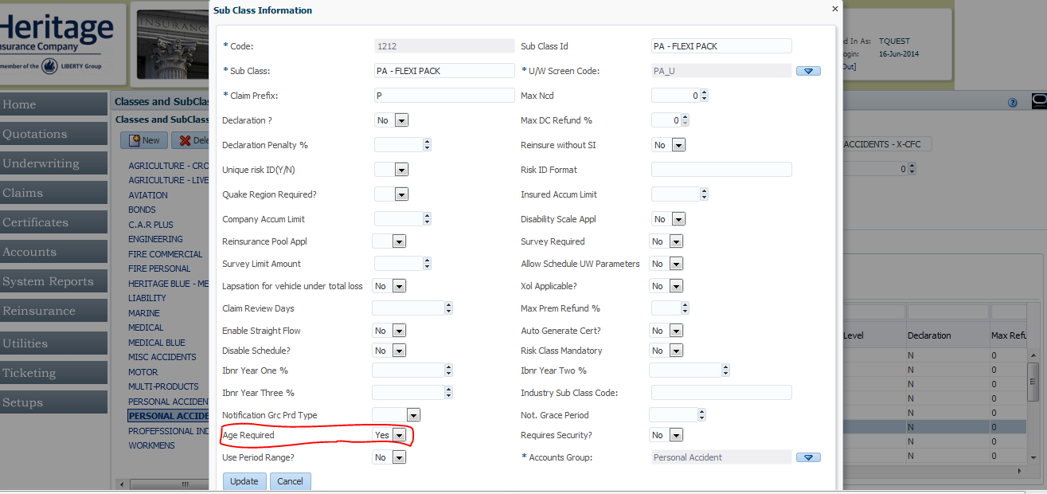

1. Specify the binder mask under **SubClass Section Perils**

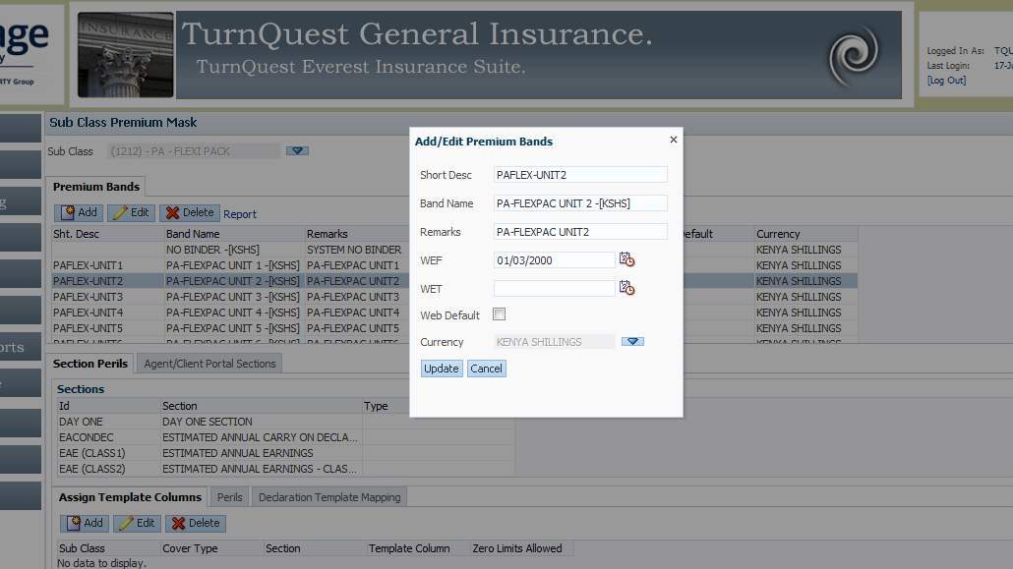

1. Specify a section to be used in defining the premium rate computations under **Sub Class Sections & Cover Types**

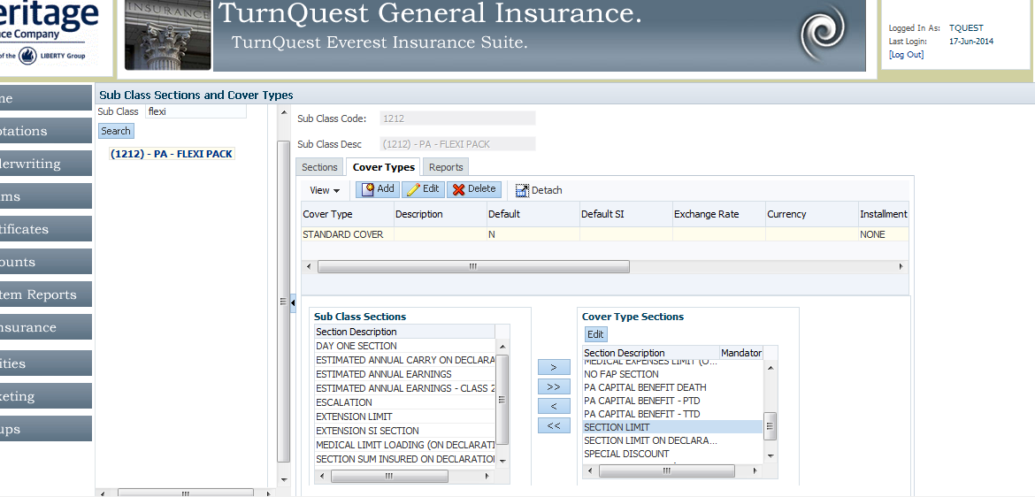

1. Under the premium rate specify the rates as shown in the snapshot below:- Note the parameters Range From – is used to specify the Age from , Range To – To specify the Age To, Rate – to specify the premium and Frequency to specify the policy frequencies to which the rate is applicable i.e.(Annual, Semi- Annual, Monthly and Quarterly)

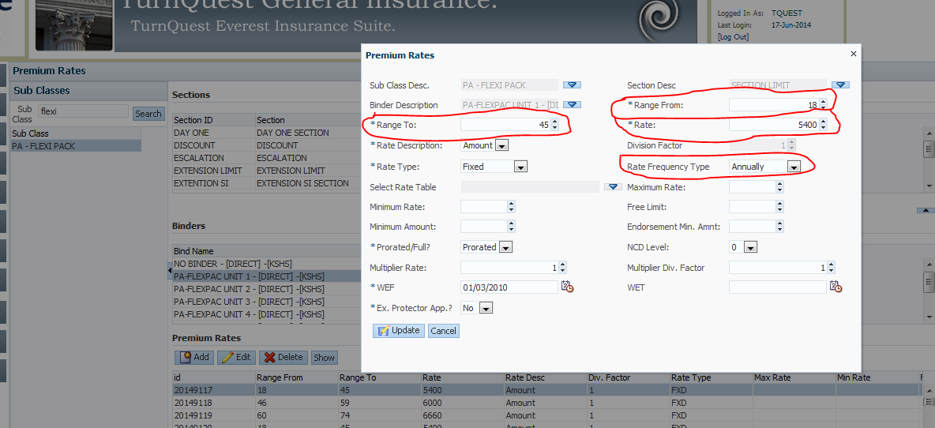

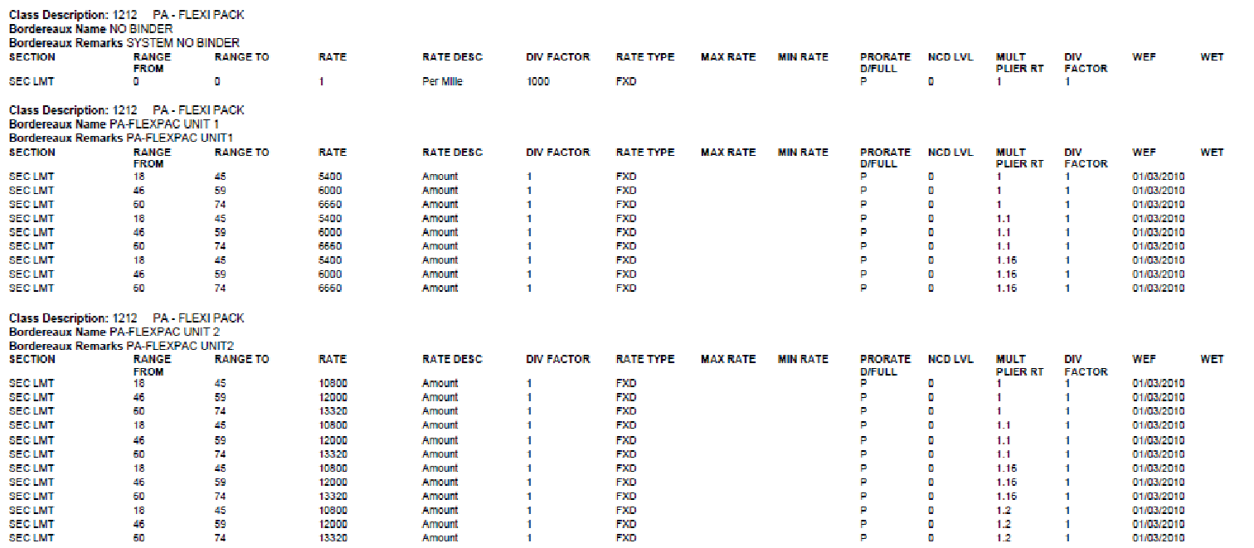

1. Specify the commission rates applicable for agents and brokers. Under **Commission Rates**

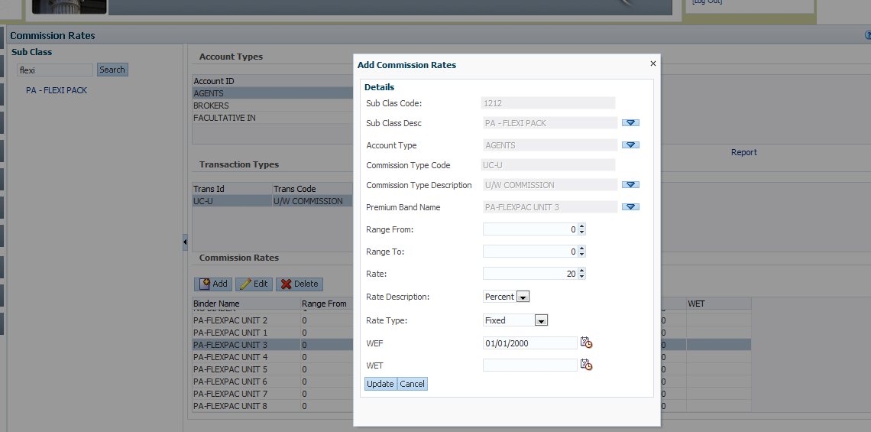

1. PI Setup

Based on the uniqueness of PI computation the following are the step to config PI.

1. Specify the Section under Liability Loading. This section provides the ability to specify the Liability for which is used to get the multiplier is used to compute the premium

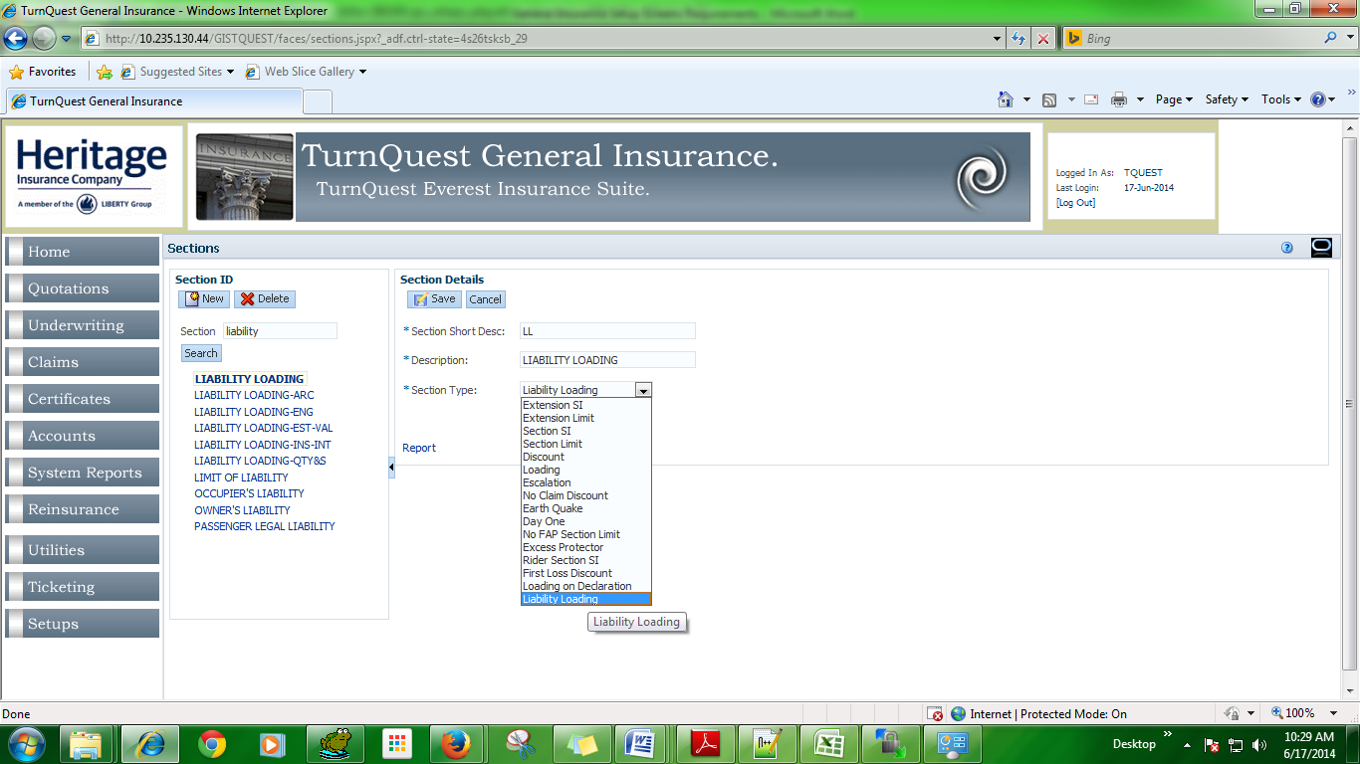

1. Attach the Section to the subclass Cover type.

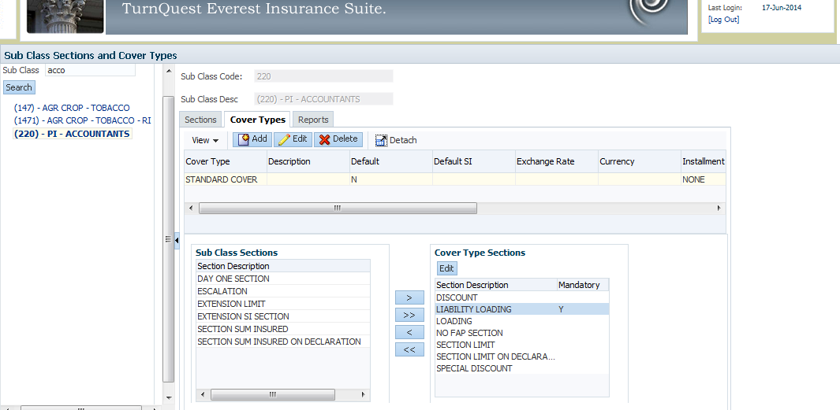

1. Under the Premium rates specify the Multiplier rate by specifying the range from and range to which are the liability range for which the multiplier is applicable. Note the loading is a value above 100%

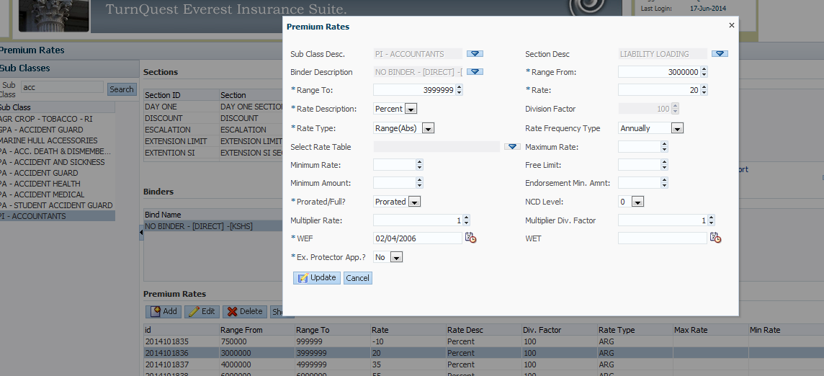

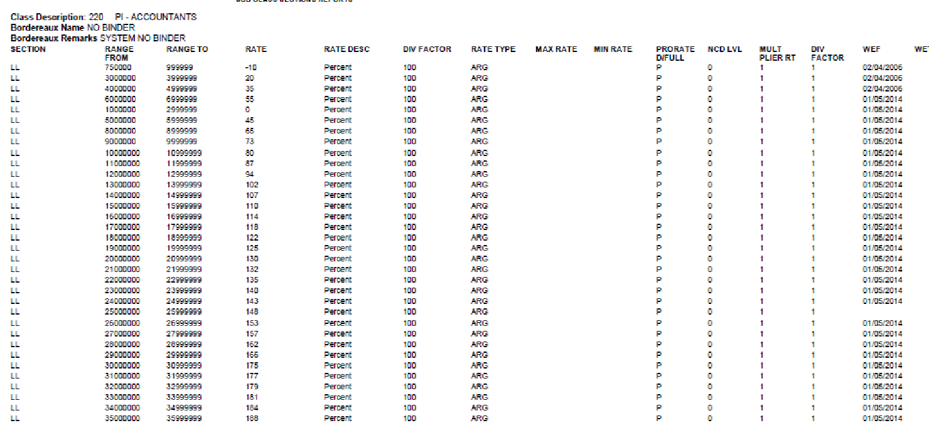

Note:- For PI premium computation the system work as so:-

Section Insured(Fee Amt) * 5% = Fee Premium

Fee Premium * Multiplier(For a specified Liability) = Liability Premium +

**PREMIUM**

**EG**

**700 000 * 5% = 35000**

**350000 * -10% = - 3500 +**

**31,500 = PREMIUM**

1. Yellow card setup
2. First step is to create a new subclass, which specifies the **“use period range to”** “yes” this specifies that the risk period is a factor of the premium computation.

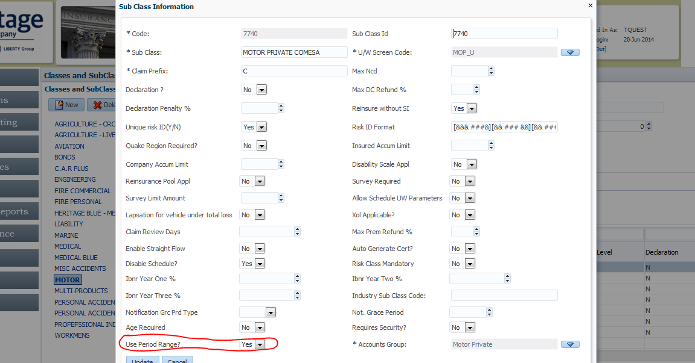

1. Attach the sections onto the subclass:-

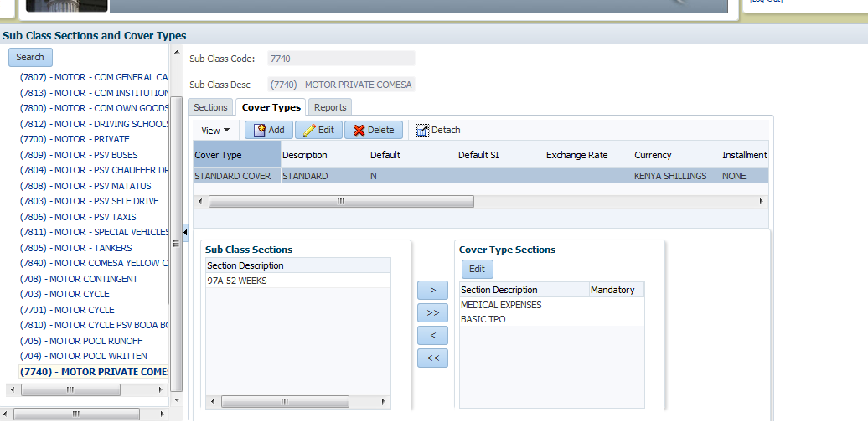

1. Specify the rates based on the risking periods as shown in the below:-

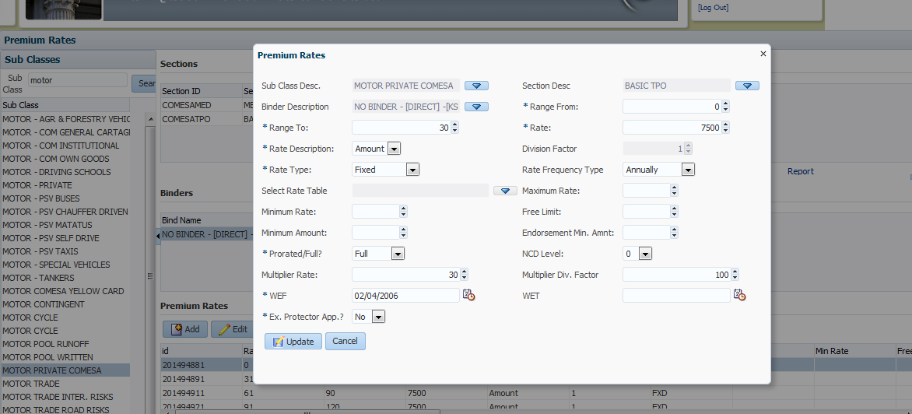

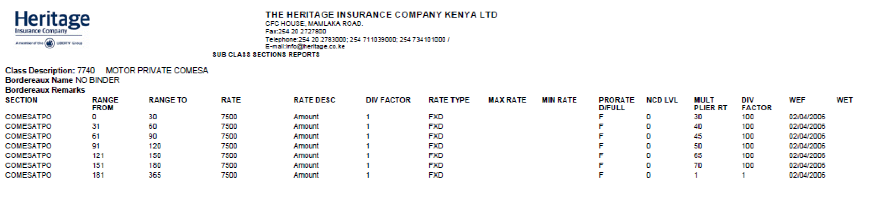

Reinsurance is then apportioned